**Steps To Create AKS Cluster**

Once you have created an Azure account, or if you already have one, please follow the steps given below in order to create an Azure Kubernetes Cluster easily.

**Step 1** Go to the Azure Portal and search for **Kubernetes Service**in the search bar and click on it.

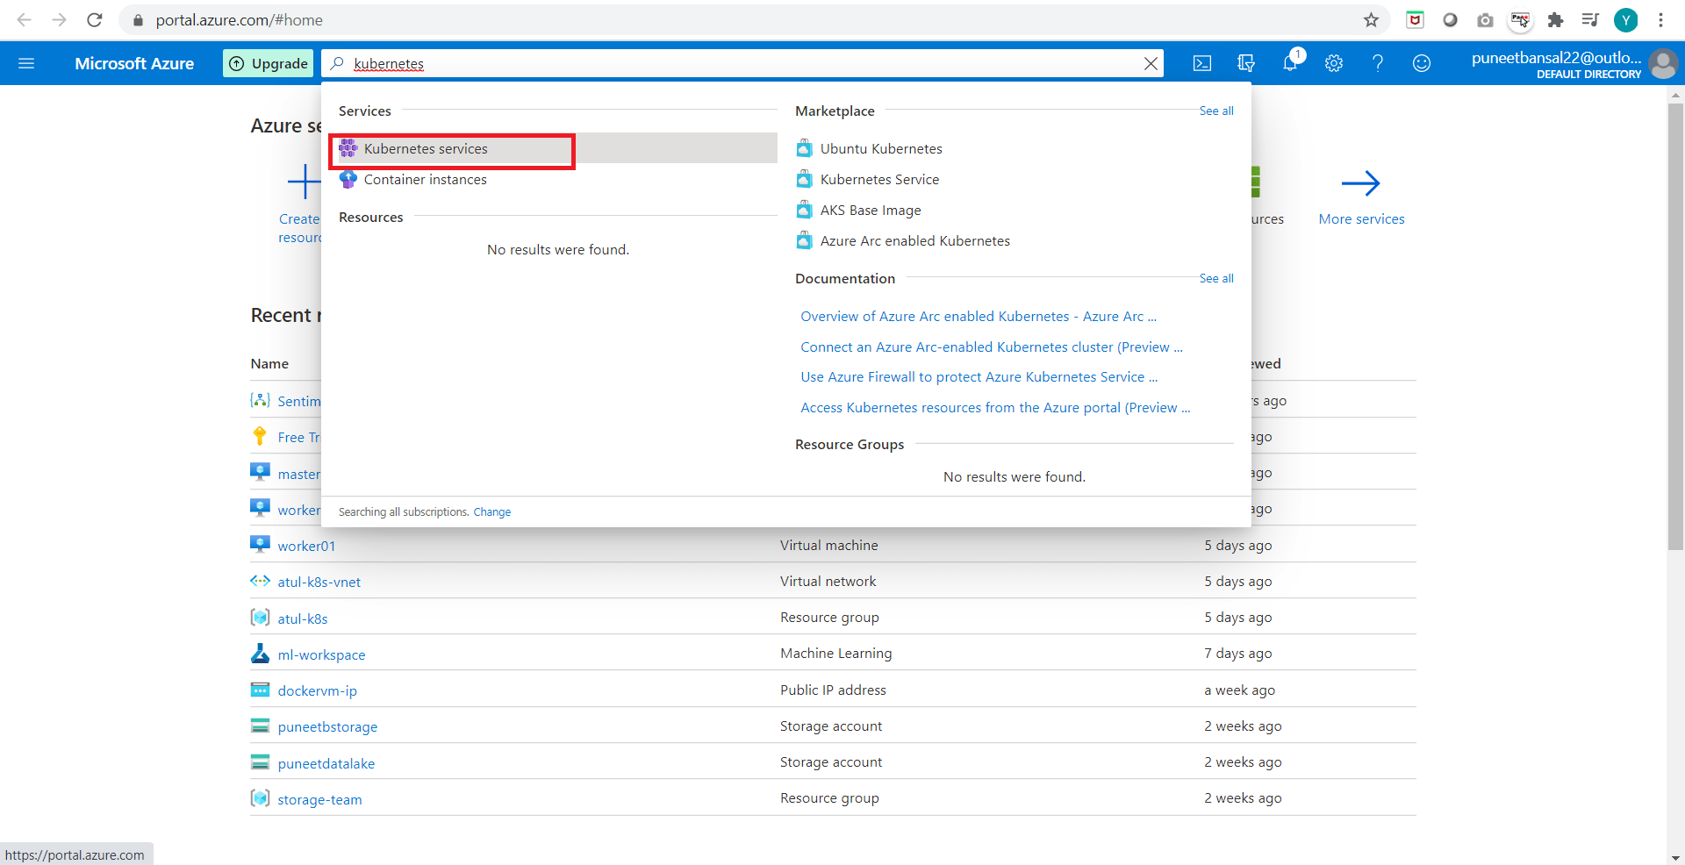

**Step 2:** Once you reach the Kubernetes Services page, click on **Create**and then **Create Kubernetes Cluster**.

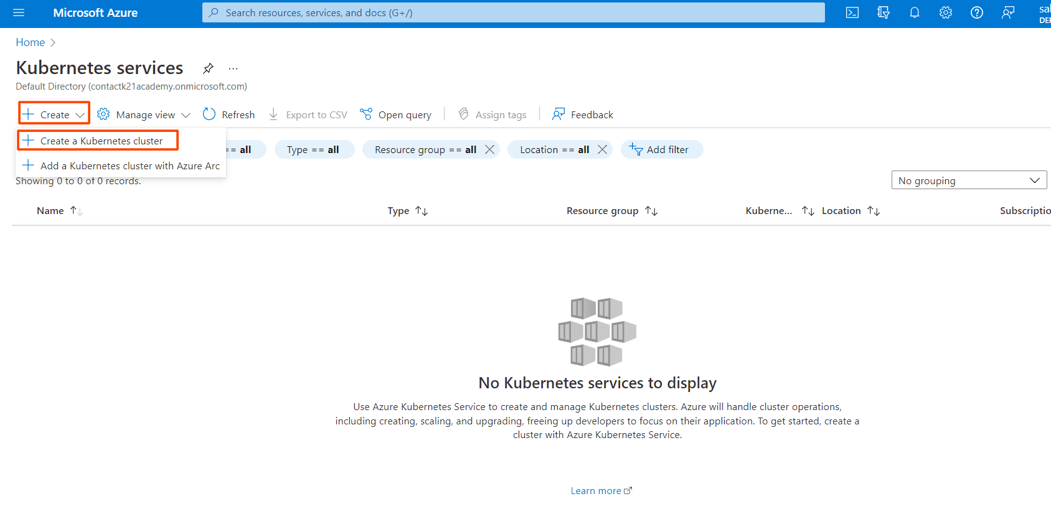

**Step 3 :**Once you click on add Kubernetes cluster, the next step is to update the specifications of the cluster. So, click on **Basics**.

* Give the **Resource Group**name as per your requirement.
* Specify a name to your cluster in**the Kubernetes cluster name**field.
* Choose a **Region** in which you want to create your AKS cluster. In the specified region, our master node will be created.
* Based on the region the select the **availability zones**.
* Select the **Kubernetes Version.**Choose default

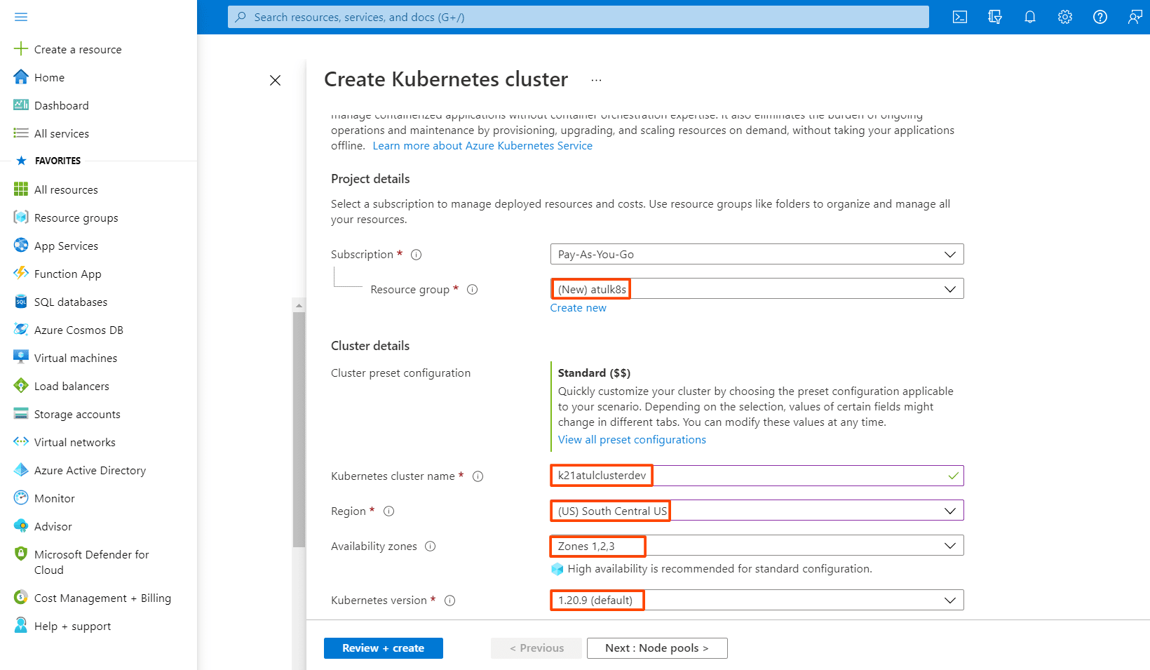

Next, comes the size and count of the nodes of the AKS cluster that we are gonna create. These can be updated as per the requirements.

* Select the **Node Size.**We are choosing **Standard Ds2 v2**which has the following configuration: 2 vCPUs, 7 GiB RAM, 8 Data Disks, 14 GiB Temp Storage.
* Give the **Node Count** value which specifies how many Worker Nodes we want.

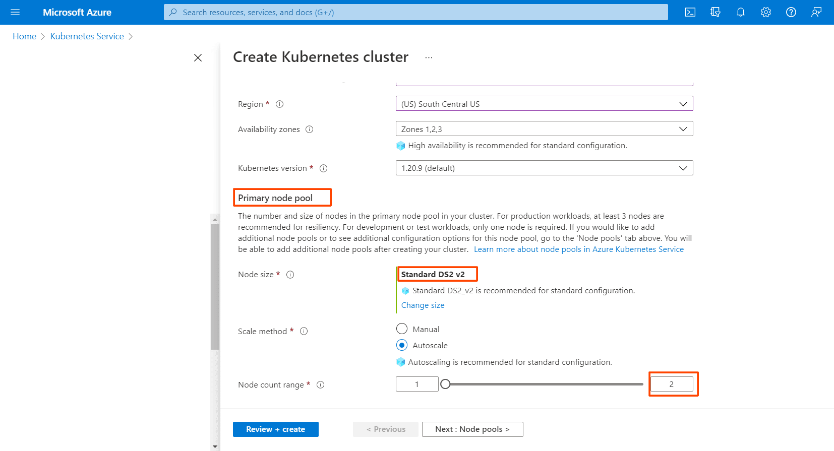

**Step 4 [Node Pools]:**Next comes the **Node Pools**, follow the steps given below:

* In Azure Kubernetes Service (AKS), nodes of the same configuration are grouped together into **node pools**. **Node pools** contain the underlying VMs that run your applications.
* The **Virtual nodes**are a type of Serverless container instance. As we want to create the Worker nodes as Virtual Machines, so we **won’t enable** this option.

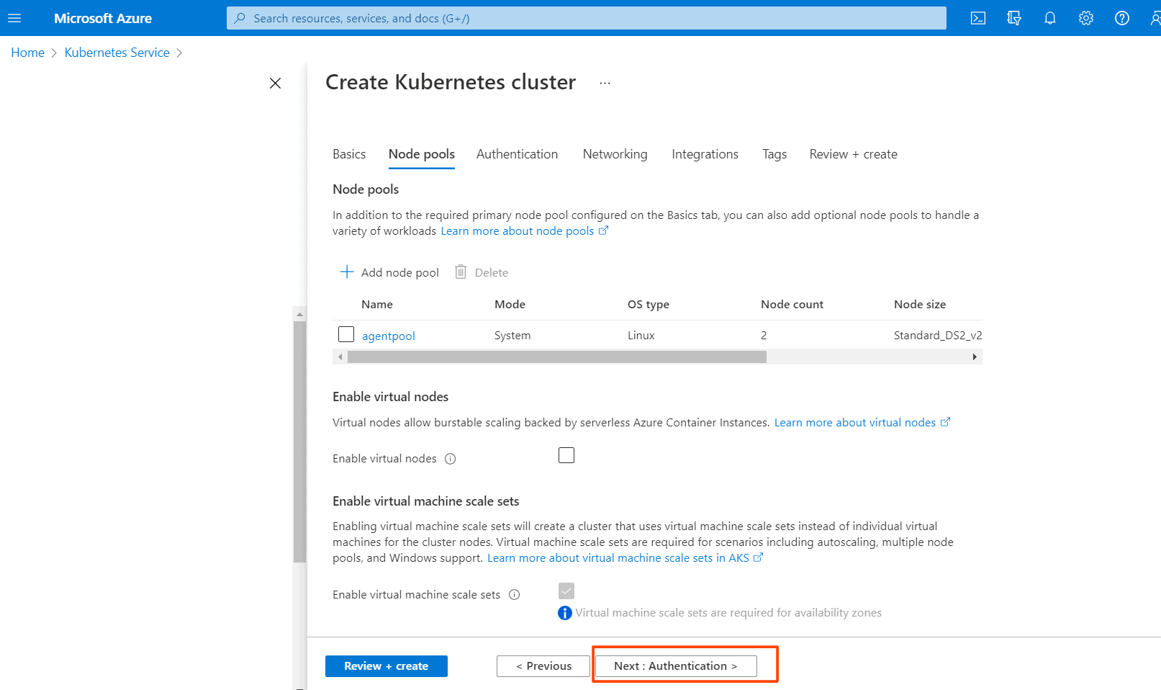

**Step 5 [Authentication]:** Next is to click on **Authentication**.

* Choose the**System-assigned managed identity.**
* If you want to go for **Role-based Access Control**(**RBAC)** then select **Enabled.**
* We can use both **RBAC** & **Azure Active Directory** for Authentication.
* **Note:** Here in this step-by-step guide, we are using both RBAC & Azure AD for authentication.
* Check the Azure Active Directory option.
* Create a group in Active Directory and add it.
* Choose the **Encryption Type** of your choice, I will use the Default one.

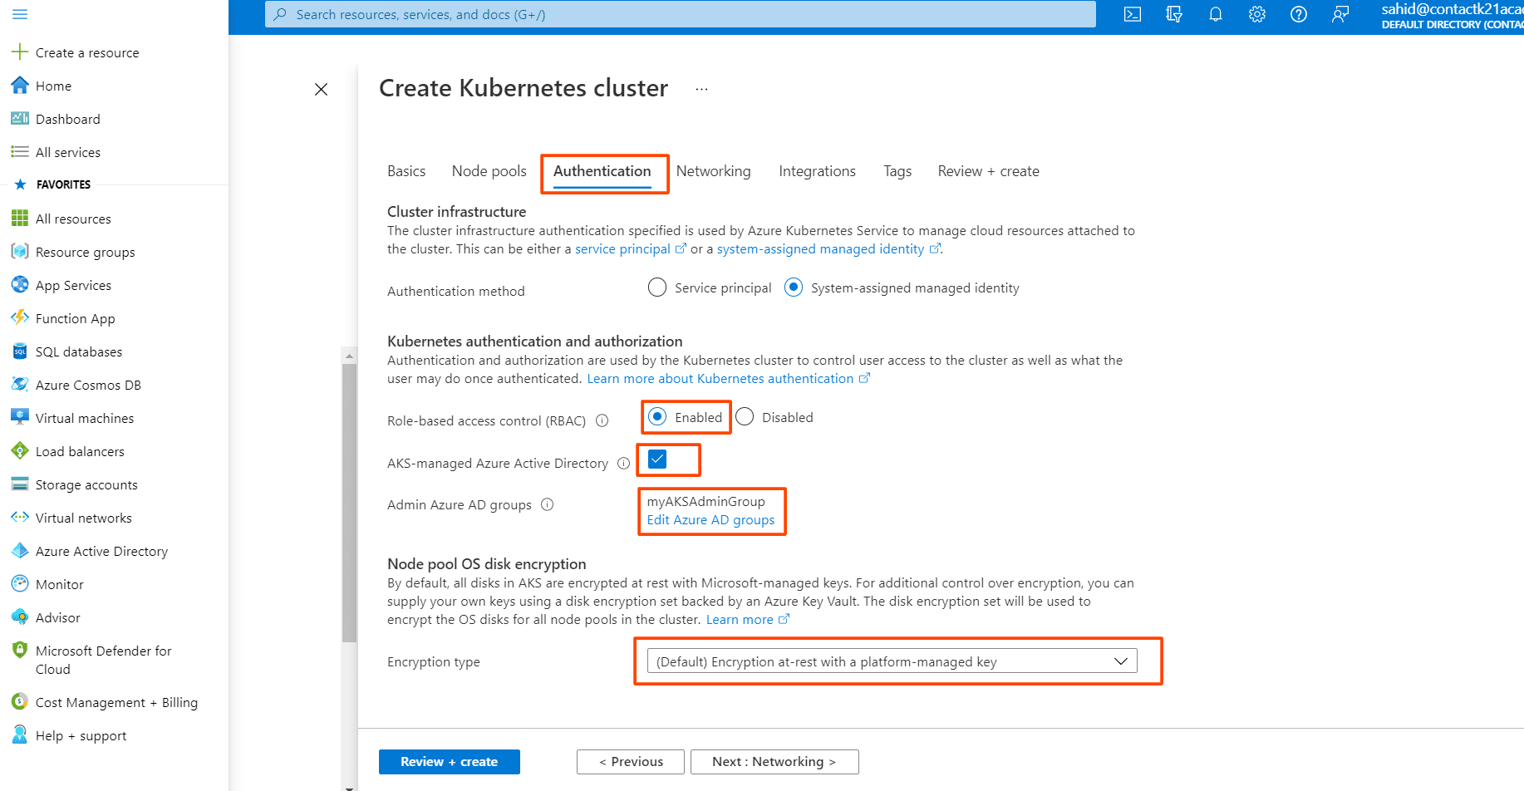

**Step 6 [Networking]:** Next is the**Networking**part.

* Select the **Network Configuration.**I will be choosing**Azure CNI**
* The **Cluster Subnet**option is to choose which Subnet you want the Nodes and Containers to be placed in.
* **Kubernetes service address range**is the CIDR notation IP range from which to assign server cluster IPs.
* **Docker Bridge address**is the IP address assigned to Docker Bridge. The Bridge Network is for the container to container communication.
* In **Private Cluster**, the communication between the nodes and the API server happens internally.
* So, I am **Disabling**the Private Cluster.
* Keep the Network Policy to **Azure**.
* Do not enable**HTTP**application routing.

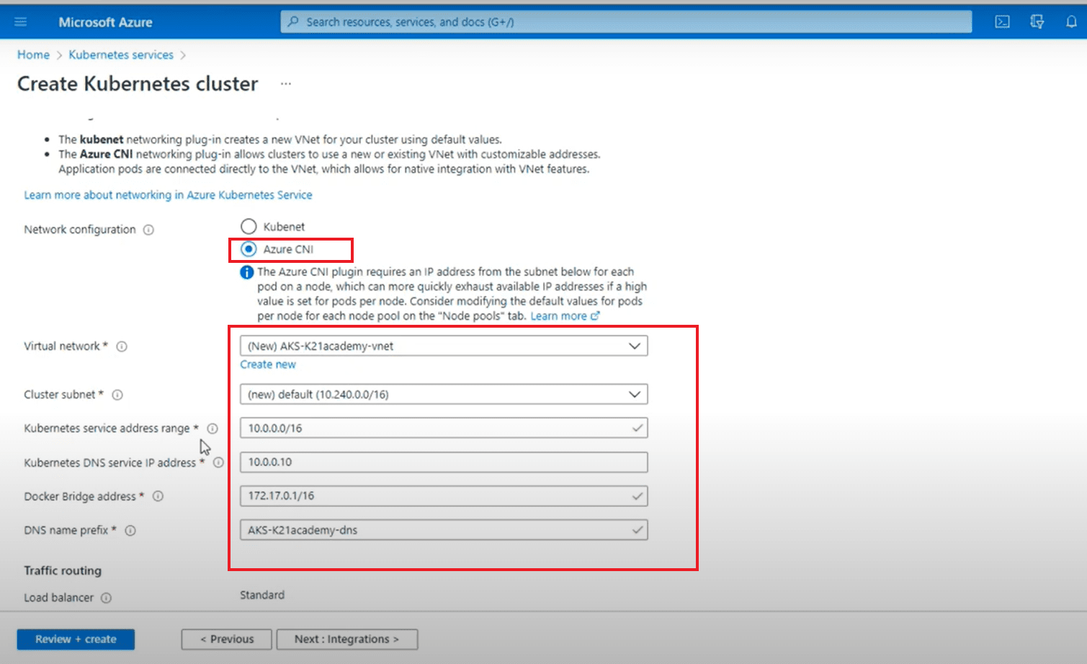

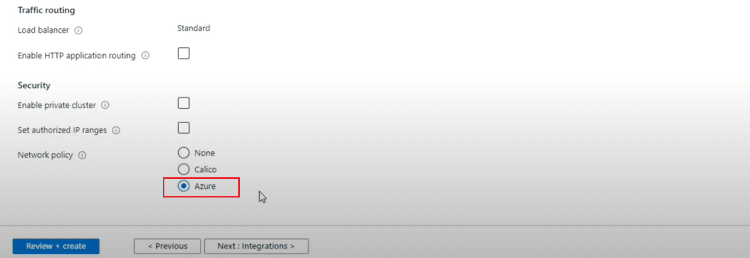

**Step 7 [Integration]:**Next is the **Integration.**

Here we keep all settings to default and move to the next step.

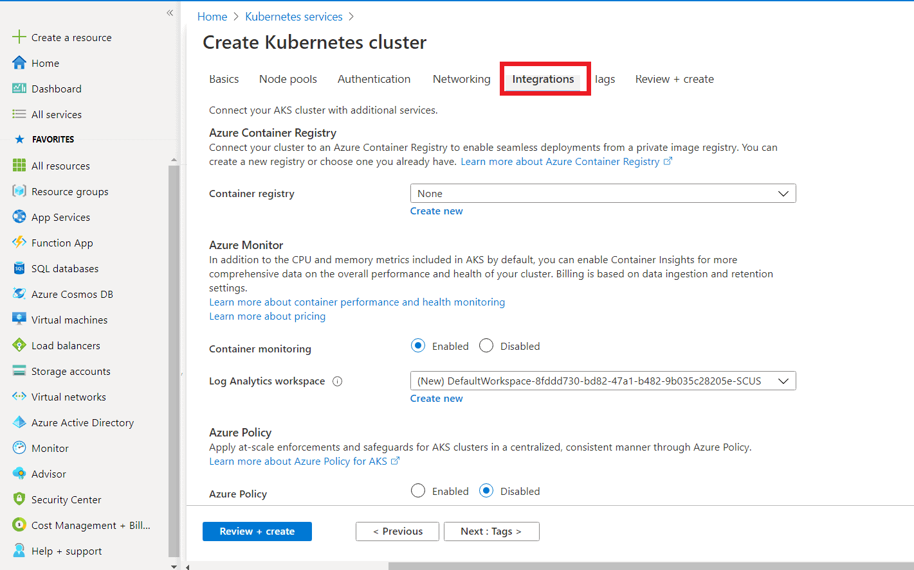

**Step 8 [Review & Create]:**The final step is to click on **Review & Create.** If you click on **Create**, it will first Validate your  AKS Cluster and if everything is fine then the cluster will be created.

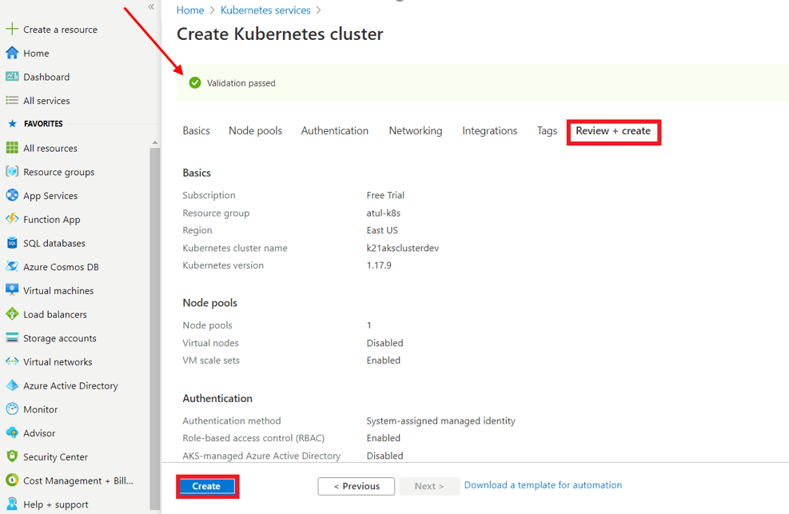

You can see that our new Azure Kubernetes cluster has been successfully created. But hold on, we will have to connect this cluster, which I am going to cover next.

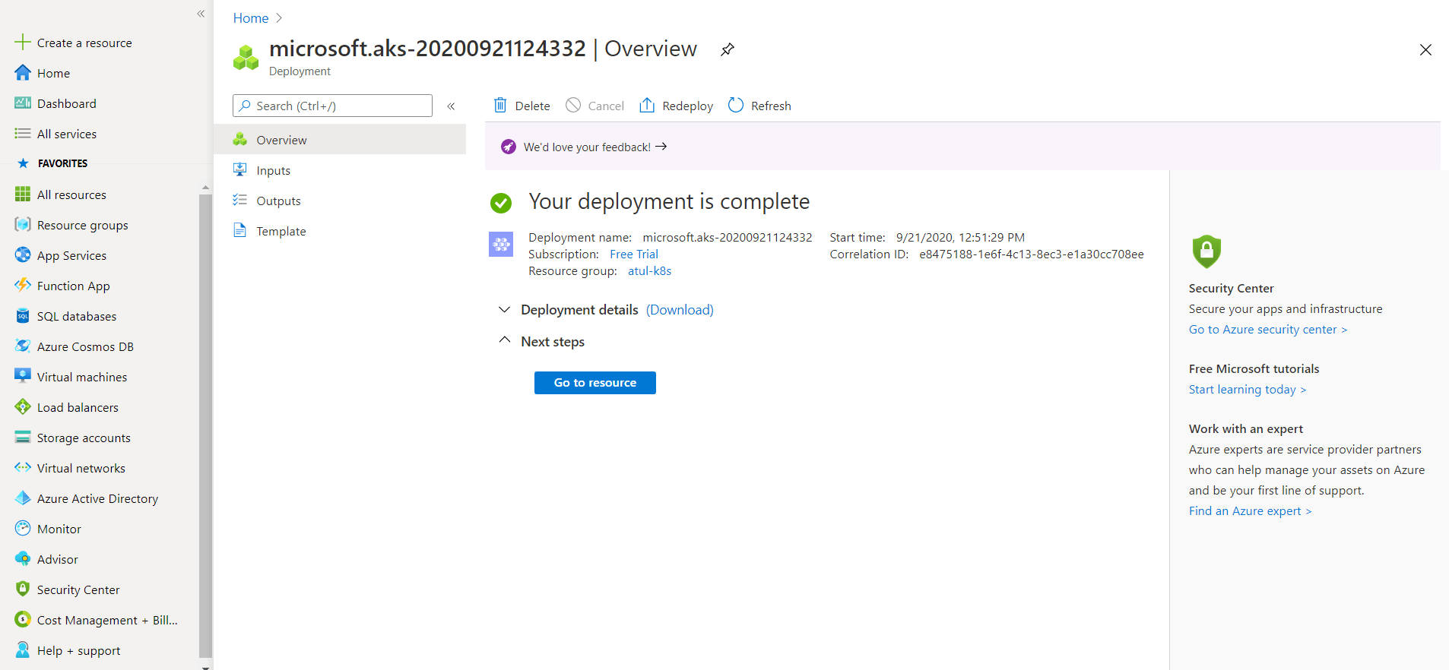

To view the cluster, go to **Kubernetes services** and there you can access the AKS cluster.

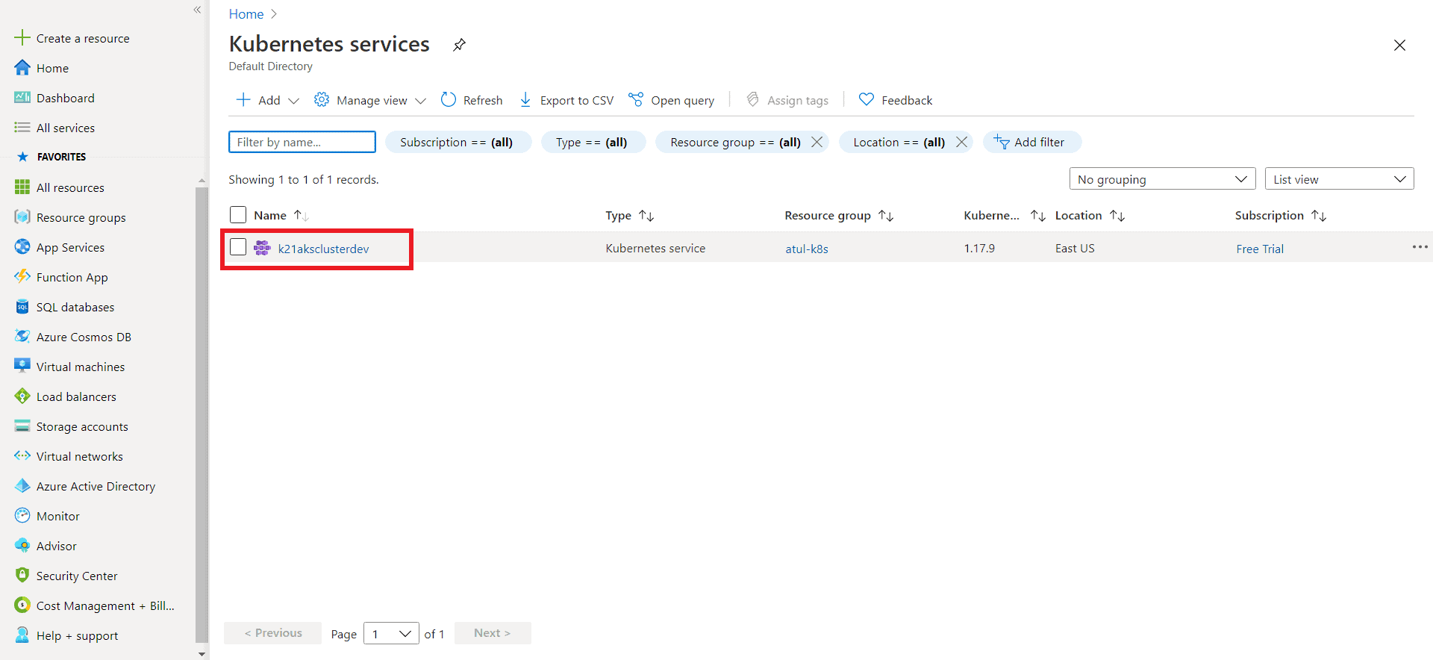

**Connect to the Azure Kubernetes Cluster**

There are two ways to connect the AKS cluster:  
**I)**Using Cloud Shell  
**II)**Using Azure CLI

I am going to cover how do we connect using **Cloud Shell**. We can see the option on top of our screen (marked red in the below image).

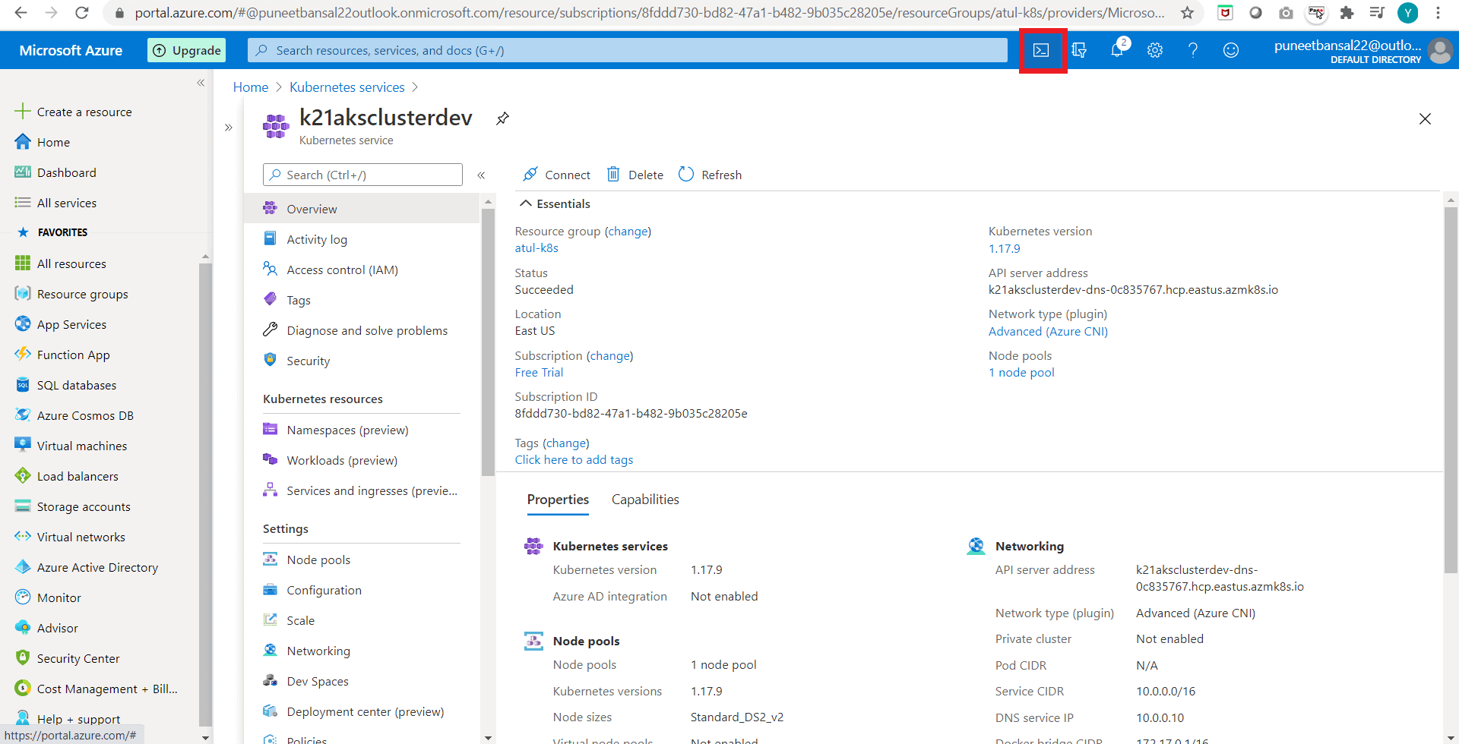

**Step 1:**Run the following command, on the Azure bash shell:

$ az aks get-credentials --resource-groups <name of resource group> --name <name of cluster>

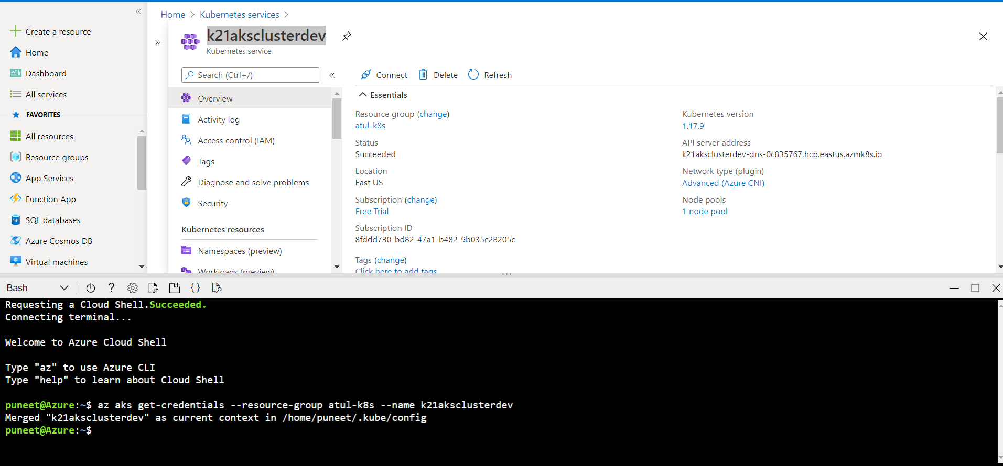

**Step 2:**To get the Nodes running in our cluster, run the following command, and you will see all the nodes in your AKS cluster.

$ kubectl get nodes

